[Preliminary Steps]
*Install VC_redist.x86.exe
[Installation]: *Place the files extracted from LandTiger.zip in "<KEIL_INSTALL_PATH>_v5\ARM\BIN"
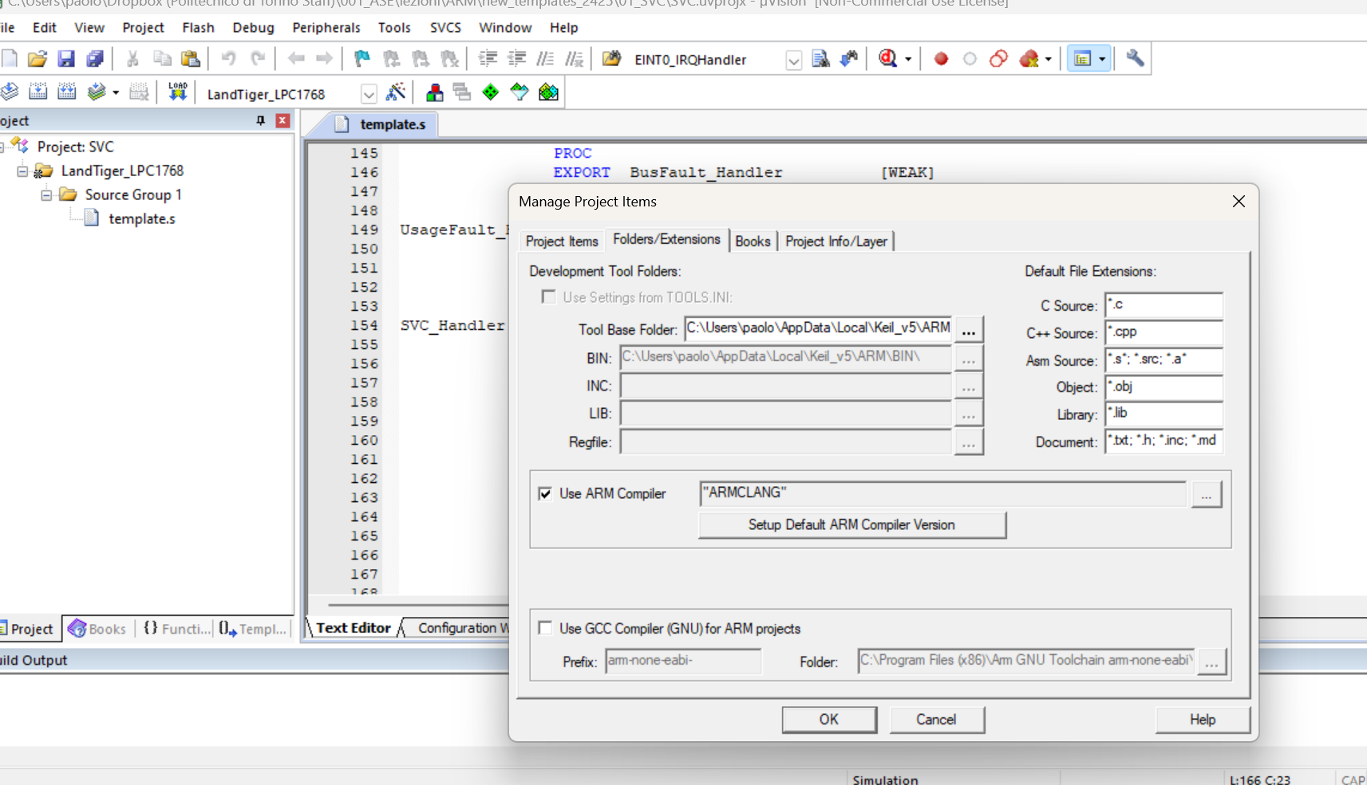
[Usage]: *Open KEIL *Options for Target -> Go to the "Debug" tab *On the "Parameter" textbox next to "Dialog DLL" type "-dLandTiger"; when the job is done it should be:
"Parameter" -> "-pLPC1768 -dLandTiger"
Click here
<keil_install_path>

